A

**PROJECT REPORT**

ON

**LASER SECURITY SYSTEM**

*Submitted to*

## STATE BOARD OF TECHNICAL EDUCATION & TRAINING, TS

***In partial fulfilment of the requirement for the award of the degree of***

**DIPLOMA**

**In**

## ELECTRONICS AND COMMUNICATION ENGINEERING

**Submitted By**

**K.SAI SHIVANI (20261-EC-034)**

#### Under the Esteemed guidance of

#### Mrs. G.SUMATHA

**Assistant Professor ECE Dept.**



**DEPARTMENT OF ELECTRONICS AND COMMUNICATION ENGINEERING JYOTHISHMATHI INSTITUTE OF TECHNOLOGY &SCIENCE SECOND SHIFT POLYTECHNIC -261**

**(Approved by A.I.C.T.E & Affiliated to SBTET, Hyderabad)**

**Nustulapur, Karimnagar – 505481, Telangana (2022–2023)**

## JYOTHISHMATHI INSTITUTE OF TECHNOLOGY & SCIENCE SECOND SHIFT POLYTECHNIC - 261

#### (Approved by A.I.C.T.E & Affiliated to SBTET, Hyderabad)

**Nustulapur, Karimnagar – 505481, Telangana (2022–2023)**



**CERTIFICATE**

This is to certify thatK .SAI SHIVANI (20261-EC-034), A .SRIJAN (20261-EC-046), ABDUL SIRAJ (20261-EC-025), D.GANESH (20261-EC-022), V.SHARATH CHANDRA

PRASAD (20261-EC-059), S.HARSHINI (20261-EC-003) Has successfully completed the Project entitled “**LASER SECURITY SYSTEM”**in the partial fulfilment for the award of **Diploma in Electronics and Communication Engineering** during the academic year 2022- 2023.

**PROJECT GUIDE HEAD OF THE DEPARTMENT**

#### Mrs.G.SUMATHA Mr. P.SAI KRISHNA M.Tech

**Assistant Professor Assistant Professor**

**ECE Dept. ECE Dept**.

**EXTERNAL EXAMINER**

# ACKNOWLEDGEMENT

We wish to pay my thanks to **Dr.K.S RAO, Principal**, Jyothishmathi Institute of Technology and Science, Second Shift Polytechnic, Karimnagar for providing all required facilities and his support during the Project work.

Our indepth thanks to the Incharge of Diploma **Mr.CH.SAJAN RAO**, **Associate Professor** Department of EEE, Jyothishmathi Institute of Technology and Science, for providing necessary facilities throughout the Project work. We would like to thank**, Mr.P. SAI KRISHNA, Assistant Professor & HOD ECE Department,** for his valuable suggestions during the Project work.

We sincerely extend our thanks to project coordinator **Mr.A.RAJU Assistant Professor Department of ECE**, valuable time in conducting presentations and also providing their feedback with a lot of useful suggestions.

Wewould like to thank**,** Project Guide**Mrs.G.SUMATHA, Assistant Professor ECE Department,** for her guidance during the Project work.

We also thank all the **Faculty Members**, Department of Electronics and Communication Engineering for their encouragement and assistance.

## PROJECT ASSOCIATE

**K .SAI SHIVANI (20261-EC-034)**

# DECLARATION

We hereby declare that this Project Report on **“LASER SECURITY SYSTEM”** submitted in the department of **Electronics and Communication Engineering,** Jyothishmathi Institute of Technology and Science, Second Shift Polytechnic, Karimnagar in partial fulfilment of the requirement for the award of the **Diploma in Electronics and Communication Engineering** is a bonafide record of our own work carried out under the supervision of **Mrs.G.SUMATHA, Assistant Professor, ECE Dept.**

Also, we declare that the matter embodied in this report has not been submitted for the award of any degree of any other institution or university previously.

## PROJECT ASSOCIATE

**K .SAI SHIVANI (20261-EC-034)**

# CONTENTS

**LIST OF FIGURES** i

ABSTRACT ii

CHAPTER-1

INTRODUCTION 1

* 1. Overview of the Project 1
  2. Introduction to Project 1
  3. Aim of the Object 2

CHAPTER-2

LITERATURE REVIEW 3

CHAPTER-3

HARDWARE COMPONENTS 5

* 1. 555 Timer 5
  2. Bread Board 11
  3. Resistors 14
  4. Capacitors 16
  5. Battery 18
  6. Transistor 22
  7. IR Leds 24
  8. Buzzer 25
  9. Laser Pointer 28

CHAPTER-4

PROPOSED SYSTEMS 30

* 1. Introduction 30
  2. Block Diagram 30
  3. Circuit Diagram 31
  4. Result 34

CHAPTER-5

* 1. Advantages 35
  2. Applications 35

CHAPTER-6

CONCLUSION 36

REFERENCES 37

# LIST OF FIGURES

### Page no.

Fig: 3.1 The brief description of the pin connections 6

Fig: 3.2 Functional Block Diagram 555 Timer 6

Fig: 3.3 555 timer connected as an astable multivibrator 9

Fig: 3.4 monostable multivibrator 9

Fig: 3.5 Bread Board 12

Fig: 3.6 Breadboard Jumper Wire Set 13

Fig: 3.7 Resistors 14

Fig: 3.8 resistor Colour coding 15

Fig:3.9 Capacitor 16

Fig 3.10 Series-Equivalent Circuit 16

Fig: 3.11 Battery 19

Fig: 3.12 Connectors 19

Fig: 3.13 Transistor 22

Fig:3.14 Construction and circuit symbol for NPN transistors 23

Fig: 3.15 Characteristic curves for a transistor 23

Fig: 3.16 Measurement parameters for hfe 24

Fig: 3.17 LED 24

Fig: 3.18 Buzzer 25

Fig: 3.19 Voltage Buzzer Sound Controls 27

Fig: 3.20 Electronic Buzzer 27

Fig: 3.21 Laser Torch 28

# ABSTRACT

This project deals with a model of laser security alarm system design. Laser security system used to be difficult to install and rarely available to anyone other than the super-rich. But now there are dozens of different security systems on the market that utilize lasers. And this system protect everything from small apartments to large area of properties. Most home laser security system consist of two parts, a basic alarm unit and an infrared motion detector. Alarm system that uses laser light and light sensor (LDR).

# CHAPTER – 1 INTRODUCTION

* 1. **OVERVIEW OF THE PROJECT**

A security alarm is a system design need to detect intrusion - unauthorized entry into a building or area. The word LASER stands for Light Amplification by stimulated Emission of Radiation. These are available in different types like semiconductor, infrared. GAS laser diode. This has an energy wavelength of approximately 900 nanometres with a beam divergence of 3 million radians i.e. equal to a beam width small beam width. Security alarms are used in residential commercial, industrial, and military properties for protection against burglary (theft) or property damage, as well as personal protection against intruders. Car alarms likewise protect vehicles and their contents. Prisons also use security systems for control of inmates.

Some alarm systems serve a single purpose of burglary protection: combination systems provide both fire and intrusion protection. Intrusion alarm systems may also be combined with closed-circuit television surveillance systems to automatically record the activities of intruders, and may interface to access control systems for electrically locked doors. Systems range from small, self-contained noisemakers, to complicated, multi-area systems with computer monitoring and control.

## INTRODUCTION TO PROJECT

LASER-Ray goes through long distance without scattering effect and the Ray is almost invisible. Only the radiation points and incident point are visible. So, by this security project we can make an invisible boundary of a sensitive area. There is two part of the system. One is transmitter and other is receiver. The transmitter part is built with a LASER radiator, a pair of dry cell batteries, an on-off switch and a stand to hold it.The receiver sides there are a focusing LDR (Light depending Resistor) sensor to sense the LASER continuously. The LDR sensor also holds with a stand and it connected with the main driver circuit.

The circuit has two parts. One is filtered the signal of discontinuity ray and others is alarm circuit. When anybody crossover the invisible ray the main circuit sense the discontinuity by sensor and turn on the alarm circuit.

If once the Alarm circuit is on it will 'till ringing until push the reset button. There is two option of ringing. On i the duration of ringing depends on present timer and another reset manually. Any option can be set by DPDT switch. The system has built with low cost and high performance. The power consumption of the system is very low.

## AIM OF THE OBJECT

In general security systems are used for protection here we are with a security system with Laser. The main aim of the project is to construct a simple and cheap laser security system using 555 timers. And also explore its uses in all aspects.

# CHAPTER-2 LITERATURE REVIEW

In the past few years the crimes and cases within Koronadal has been gradually arising reached 26.82% robbery cases with 27.42%, 2.89% and crime vs percentage 18 18% PNP annual report. 2015).The alarming percentages of crime have triggered the researchers to create this research project.

In this chapter the researches have made available complications of information on laser and its significance to the innovations of security. The following accounts will be for greater attainment of understanding about laser and security systems. Studies about how these technologies have come into reality and the efforts of humanity to elevate the innovations of the past generations up to the present era.

Since the beginning light has played a great role in the life of humanity. With man’s curiosity, they have harnessed light and created things out of the ordinary. Light can be seen fluorescent, incandescent, LED lights and laser. The light from a laser is very different from ordinary light that is produced by a torch. It is different in three ways. Firstly, it is more powerful. Lasers can therefore be used to cut very hard objects. Secondly, laser light spreads out much less than ordinary light. This mean, the laser can be used by surveyors to draw straight lines and measure distances. Lastly, laser light contains light of only one colour, or wavelength whereas ordinary light is a mixture of many colours.

Since the discovery of laser it has been experimented with to explore various purposes and harness the benefits of man’s effort. When it was first invented, it was proved to be a difficult tool to use. Some people thought that the new invention would be of no real value to science or engineering. Today, the laser has a hundreds; if not thousands of uses.

Nowadays, it is useful in many fields. For example, in medicine, it is use as an instrument in delicate surgery, in communications; it proves to be useful with the help of optical fibbers to carry telephone conversations. The information is put into the fibre through laser beams. Also, surveyors have benefited with the discovery of laser, as it produces a near perfect line, it is used for accurate alignment.

The military has also found many uses for lasers like the "marked target seeker" which sense laser pointed at the target and makes a direct hit. The industry of automotive uses this as heaters of parts of gear systems of cars. It was also used to measure length of distances in space "courtesy of NASA", to know the distance of planets and stars. There is also entertainment use for lasers like holography by splitting laser beams to create images for effects in films and videos. At the present, it is integrated with more uses, one of my which is applicable in security systems: Laser becomes a revolutionary discovery and still has much potential for possible use in the future.

# CHAPTER – 3 HARDWARE COMPONENTS

## 555 TIMER

#### Introduction

The 555 timer is an integrated circuit (chip) implementing a variety of timer and multivibrator applications: It was produced by Synetics Corporation in early 1970. The original name was the SE555/NE555 and was called "The IC Time Machine". The 555 gets its name from the three 5-Kn resistors used in typical carly implementations INS widely used because of its ease to use, low price and reliability.

It is one of the most popular and versatile integrated circuits which can be used to build lots of different circuits. It includes 23 transistors, 2 diodes and 16 resistors on a silicon chip installed in an 8-pin mini dual-in-line package (DIP-8).

The 555 Timer is a monolithic timing circuit that can produce accurate and highly stable time delays or oscillations. The timer basically operates in one of the two modes monostable (one- shot) multi vibrator or as an astable (free-running) multivibrator. In the monostable mode, it can produce accurate time delays from microseconds to hours. In the astable mode, it can produce rectangular waves with a variable duty cycle. Frequently, the555 is used in satiable mode to generate a continuous series of pulses, but you can also use the 555 to make a one- shot or monostable circuit.

The 555 can source or sink 200 mA of output current, and is capable of driving wide range of output devices. The output can drive TTL. (Transistor-Transistor Logic and has a temperature stability of 50 parts per million (ppm) per degree Celsius change in temperature, or equivalently 0.005 %/C.

Applications of 555 timer in monostable mode include timers, missing pulse detection, bounce free switches,and touch switches, frequency divider, capacitance measurement, pulse width Inodulation (PWM) etc.

In astable or free running mode, the 555 can operate as an oscillator. The uses include LED and lamp flashers, logic clocks, security alarms, pulse generation. Tone generation, position modulation etc. In the bistable mode, the 555 can operate as a flip- flop and is used to make bounce-free latched switches, etc.

The pin number used refers to the 8-pin Num DIP and 8-pill metal can package .The 555 can be used with a supply voltage (VCC) in the range 4.5 to 15V (18V absolute maximum).

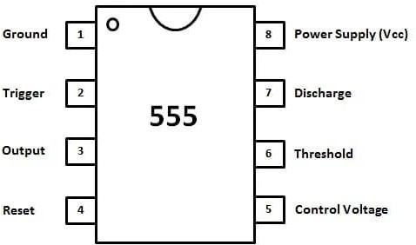

Fig 3.1The brief description of the pin connections

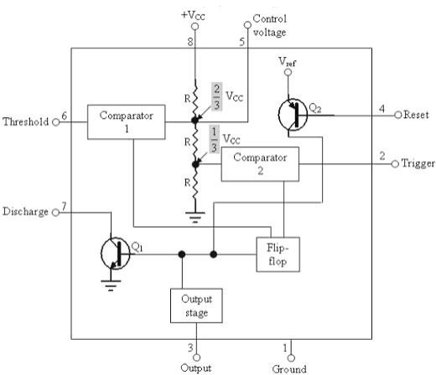

Fig: 3.2 Functional Block Diagram 555 Timer

#### The pin connections of the 555 timer are as follows:

Pin 1: Ground: All voltages are measured with respect to this terminal

Pin 2: Trigger: The external trigger pulse is applied to this pin. The output of the timer is low if the voltage at this pin is greater than (2/3) VCC.

If a negative going pulse of amplitude larger than CCV31 is applied to this pinthe output of comparator 2 becomes low, which in turn makes the output of the timer high the output remains high as long as the trigger terminal remains at low voltage.

Pin 3: Output: There are two ways a load can be connected to the output terminal either between pin3 and ground (pin 1)or between pin 3 and the supply voltage +Vee (pin 8) the output is low the load current flows through the load connected between pin 3 and pin 8 into the output terminal and is called the sink current. Therefore, the load between pin 3 and Vee is called normally "on load and that connected between pin: 3 and, ground is called "normally off load" On the other hand, when the output is high the current through the load connected between pin 3 and VCC (normally off load), is Zero. However the output terminal supplies current to the "normal off load". This current is called the source current. The maximum value of the sink or source current is 200mA.

Pin4: Reset: The 555 Timer can be reset or disabled by applying a negative pulse to this pin. When not in use, the reset terminal is connected to +Vee to avoid the possibility of false triggering.

Pins5: Control Voltage: An external voltage may be applied to this terminal to change the threshold as well as the trigger voltage. The pulse width of the output waveform is hence dependent on it. When not in use, the control pin should be bypassed to ground with a 0.01 uF capacitor to prevent any noise problems.

Pin6: Threshold: This is the non-inverting input terminal of the comparator 1. When the voltage at this pin becomes greater than or equal to the threshold voltage 2/3Vcc.the output of this comparator becomes high, which in tum switches the output of the timer low.

Pin7: Discharge: This pin is connected internally to the collector of a transistor

## SECTION A

**ASTABLE MULTIVIBRATOR**

We now take up the application of 555 timer as an astable multivibrator. An astable multi vibrator is a wave-generating circuit in which neither of the output levels is stable. The output keeps on switching between the two unstable states and is a periodic, rectangular waveform. The circuit is therefore known as an ‘astable multi vibrator’. Also,no external trigger is required to change the state of the output, hence it is also called 'free-running multivibrator'. The time for which the output remains in one particular state is determined by the two resistors and a capacitor externally connected to the 555 timer.

## APPARATUS

* CRO (cathode ray oscilloscope)
* Power supply (+SV to +18V)
* 555 timer
* Capacitors
* Connecting wire.
* Connecting leads of CRO
* Bread board
* Resistors

## THEORY

555 timer connected as an astable multivibrator. Pin 5 is bypassed to ground through a 0.01 uF capacitor. The power supply (+VCC) is connected to common of pin 4 and pin 8 and pin Ii, grounded. If the output is high initially, capacitor C starts charging toward through RA and RB A soon as the voltage across the capacitor becomes equal to VCC, the upper comparator triggers the flip-flop and the output becomes low. The capacitor now starts discharging through RB and transistor Q1. When the voltage across the capacitor becomesCCV3 L the output of the lower comparator triggers the flip-flop and the output becomes high. The cycle then repeats. The output voltage and capacitor voltage waveforms

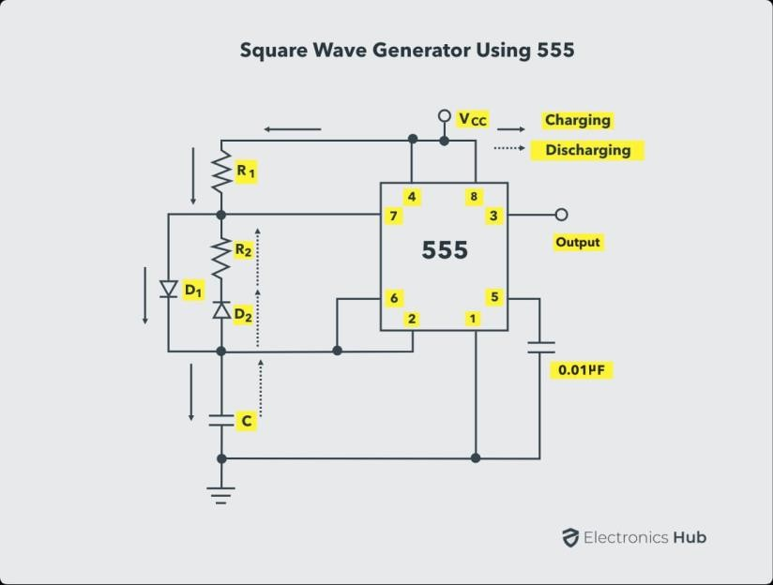

Fig: 3.3 555 timer connected as an astable multivibrator

## SECTION B

**MONOSTABLE MULTIVIBRATOR**

We now discuss another important application of 555 timer, that is, 555 timer as a monostable multivibrator. A monostable multivibrator is a pulse-generating circuit having one stable and one quasi-stable state.

Since there is only one stable state, the circuit is known as 'monostable multivibrator. The duration of the output pulse is determined by the RC network connected externally to the 555 timer

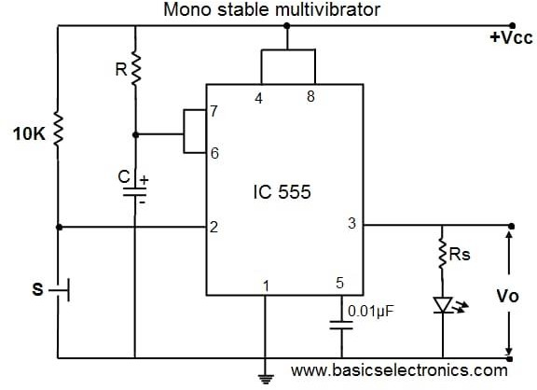

Fig: 3.4 monostable multivibrator

**Astable:** A mode in which a 555 timer has no stable state and produces a rectangular wave of predetermined frequency.

**Bistable:** A mode in which 555 timer has two stable output states and the output is latched in either of the two states

**Comparato**r**:** It is an application of op-amp and is described as a circuit that compares two analog voltages, an input voltage and a reference voltage also called the trip point the output is either a low or a high voltage

**Control voltage:** An external voltage which may be applied to change the threshold as well as the trigger voltage and hence also the pulse-width of the output waveform

**DIP:** It is an acronym for Dual-Inline Package and refers to a type of integrated circuit packaging that has two rows of external connecting terminals.

**Duty Cycle:** It is the ratio of the time for which the output of an astable multivibrator is high to the time period T of the output waveform. It is generally expressed as a percentage.

**Integrated Circuit:** A miniaturized electronic circuit consisting mainly of semiconductor devices, as well as passive components, that has been manufactured in the surface of a thin substrate of semiconductor material

**Monolithic**: The common form of chip design or an integrated circuit, in which the base material (semiconductor substrate) contains the pathways as well as the active elements that take part in its operation.

**Monostable:** A mode in which a 555 timer produces a rectangular output pulse of known pulse-width. It is also called one-shot.

**Multivibrator:** A two-state circuit with zero, one or two stable output states depending on whether it is connected in astable, monostable or bistable mode. One-shot: Same as monostable

**Threshold voltage:** The voltage given at the non-inverting input terminal of the op-amp used as the upper comparator in the block diagram of 555 timer.

**Transistor:** An active three-terminal semiconductor device that can be used either as an amplifier or as a switch. The two basic types are bipolar junction transistors (BJTs) and field effect transistors (FETs). A BJT can be either NPN or PnP.

**Transistor-Transistor Logic (TTL):** A class of digital circuits built from bipolar junction transistors and resistors. It is named so because both the logic gating function and the amplifying function are performed by transistors.

**Trigger:** It basically means to initiate an action and refers to a sharp input pulse of voltage or current used to turn on a switching device.

**Trip point:** The value of the input reference voltage of a comparator is called trip point.

## BREAD BOARD:

A breadboard is a construction base for prototyping of electronics. Originally it was literally a bread board, a polished piece of wood used for slicing bread. In the 1970s the solder less breadboard (AKA plug board, a terminal array board) became available and nowadays the term "breadboard" is commonly used to refer to these. "Breadboard" is also a synonym for "prototype". Because the solder less breadboard does not require soldering, it is reusable. This makes it easy to use for creating temporary prototypes and experimenting with circuit design.

For this reason, solder less breadboards are also extremely popular with students and in technological education. Older breadboard types did not have this property. A strip board (Vero board) and similar prototyping printed circuit boards, which are used to build semi- permanent soldered prototypes or one-offs, cannot easilybe reused.

A variety of electronic systems may be prototyped by using breadboards, fromsmall analog and digital circuits to complete central processing units (CPUs). This projectboard for experimental, non-soldered setup of electronic circuits.

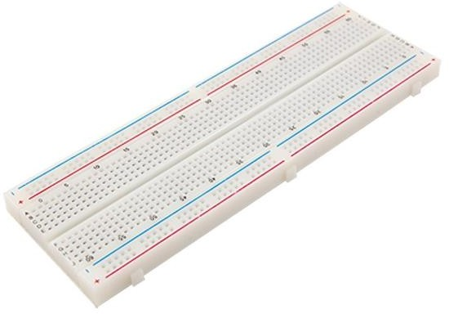

Fig: 3.5 Bread Board

### Breadboard Jumper Wire Set:

This set of jumper wires can help remove the clutter on breadboard. It comes in 14 different lengths and 8 colors to keep circuit on the surface. All of them are pre- formed and pre- sorted. We can easily find the color and length that need within a sec. A jump wire (also known as jumper, jumper wire, jumper cable. DuPont wire, or DuPont cable named for one manufacturer of them) is an electrical wire, or group of them in a cable with a connector or pin at each end (or sometimes without them simply "tinned") which is normally used to interconnect the components of a bread board or other prototype or test circuit, internally or with other equipment or components, without soldering.

Individual jump wires are fitted by inserting their "end connectors" into the slots provided in a breadboard, the header connector of a circuit board, or a piece of test equipment,

There are different types of jumper wires. Some have the same type of electrical connector at both ends, while others have different connectors. Some common connectors are:

* + - * **Solid tips:** Are used to connect on/with a breadboard or female header connector. The arrangement of the elements and ease of insertion on a breadboard allows increasing the mounting density of both components and jump wires without fear of short-circuits. The jump wires vary in size and colour to distinguish the different working signals
      * **Crocodile clips:** Are used, among other applications, to temporarily bridge sensors. buttons and other elements of prototypes with components or equipment that have arbitrary connectors, wires, screw terminals, etc.
      * **Banana connectors:** Are commonly used on test equipment for DC and low-frequency AC signals.
      * **Registered jack (Rinn):** Are commonly used in telephone (RJII) and computer networking (RJ45).
      * **RCA connectors:** Are often used for audio, low-resolution composite video signals, or other low-frequency applications requiring shielded cables.
      * **RF connectors:** Are used to carry radio frequency signals between circuits, test equipment, and antennas.

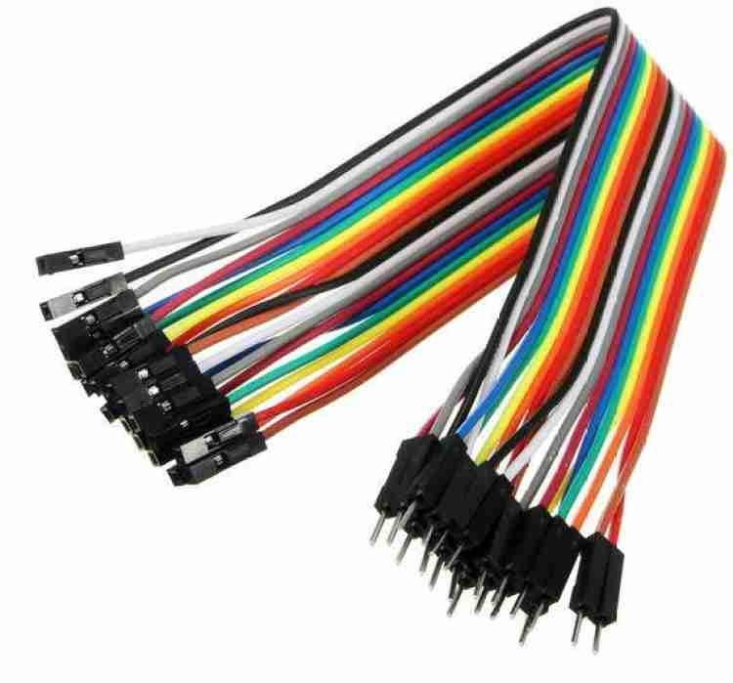

Fig: 3.6 Breadboard Jumper Wire Set

## RESISTORS:

A linear resistor is a linear, passive two terminal electrical component that implements electrical resistance as a circuit element. The current through a resistor is in direct proportional to the voltage across the resistor's terminals

Thus, the ratio of the voltage applied across a resistor's terminals to the intensity of current through the circuit is called resistance. This relation is represented by Ohm's law:

I=V/R

Resistors are common on elements of electrical network sand electronic circuits and are ubiquitous in most electronic equipment.

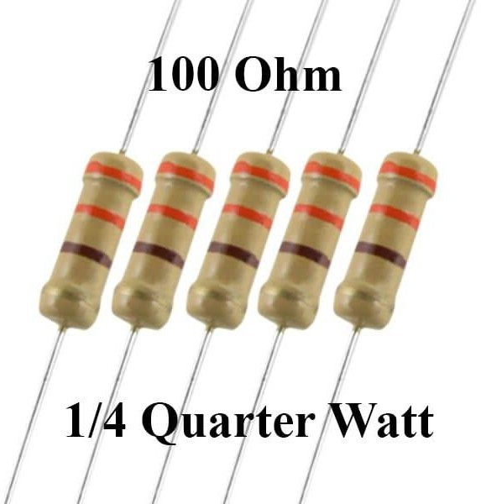

Fig: 3.7 Resistors

### Resistor Color Codes

Resistance values Tolerance values al 0 Black Brown 1%

II 1Brown. II Red +2% 2-Red Gold 5%

MI 3=Orange Silver± 10% 4=Yellow

5=Green II6=Blue III=Violet 41R=Grey

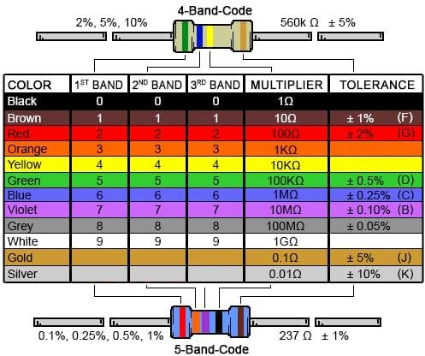El 9=White

Fig: 3.8 resistor Colour coding

## CAPACITOR:

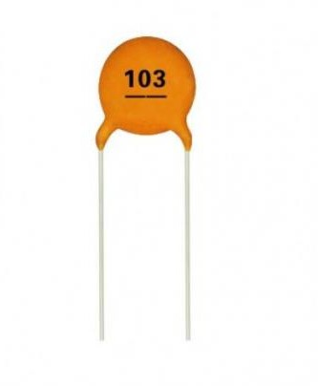A capacitor is a passive two-terminal electrical component that stores potential energy in an electric field. The effect of a capacitor is known as capacitance. While some capacitance exists between any two electrical conductors in proximity in a circuit, a capacitor is a component designed to add capacitance to a circuit. The capacitor was originally known as a condenser.

Fig:3.9 Capacitor

### *Series-equivalent circuit model of a ceramic capacitor*

All electrical characteristics of ceramic capacitors can be defined and specified by a series equivalent circuit composed out of an idealized capacitance and additional electrical components, which model all losses and inductive parameters of a capacitor. In this series- equivalent circuit the electrical characteristics of a capacitors is defined by C, the capacitance of the capacitor, Rinsul, the insulation resistance of the dielectric, not to be confused with the insulation of the housing RESR, the equivalent series resistance, which summarizes all ohmic losses of the capacitor, usually abbreviated as "ESR". LESL, the equivalent series inductance, which is the effective self-inductance of the capacitor, usually abbreviated as "ESL"

The capacitance (C) of the capacitor is equal to the electric charge (Q) divided by the voltage (V):

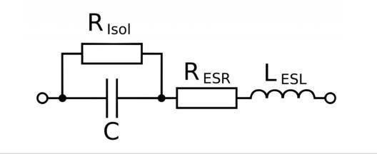

Fig 3.10 Series-Equivalent Circuit

C=\frac{Q}{V}

C is the capacitance in farad (F)

Qis the electric charge in coulombs (C), that is stored on the capacitor V is the voltage between the capacitor's plates in volts (V) Capacitance of plates capacitor

The capacitance (C) of the plate’s capacitor is equal to the permittivity (e) times the plate area

A) divided by the gap or distance between the plates (d):

C=Ad

Cis the capacitance of the capacitor, in farad (F).

C is the permittivity of the capacitor's dialectic material, in farad per meter (F/m). A is the area of the capacitor's plate in square meters (m2).

D is the distance between the capacitor's plates, in meters (m). The total capacitance of capacitors in series, C1, C2, C3...: C=C1+C2+C3+...

The total capacitance of capacitors in parallel, C1, C2, C3... CTotal =C1+C2+C3+...

Capacitor's current

The capacitor's momentary current IC(t) is equal to the capacitance of the capacitor, times the derivative of the momentary capacitor's voltage VC(t):

IC (t) =Cdvc (t) dt Capacitor's voltage

The capacitor's momentary voltage VC(t) is equal to the initial voltage of the capacitor, plus 1/C times the integral of the momentary capacitor's current IC(t) over time t:

Energy of capacitor

The capacitor's stored energy EC in joules (J) is equal to the capacitance (C) in farad (F) times the square capacitor's voltage VC in volts (V) divided by 2:

EC=C×VC2/2

## BATTERY

The nine-volt battery format is commonly available in primary carbon-zinc and alkaline chemistry, in primary lithium iron disulphide, and in rechargeable form in nickel- cadmium, nickel-metal hydride and lithium-ion. Mercury-oxide batteries of this format. Once common, have not been manufactured in many years due to their mercury content. Designations for this format include NEDA 1604 and IEC 6F22 (for zinc-carbon) or MN1604 6LR61 (for alkaline). The size, regardless of chemistry, is commonly designated PP3-a designation originally reserved solely for carbon-zinc, or in some countries, E or E-block most nine-volt alkaline batteries are constructed of six individual 1.5 v. LR61 cells closed in a wrapper. These cells are slightly smaller than LR8D425 AAAA cell and can be used in their place for some devices, even though they are 3.5 mm shorter Caine types are made with six flat cells in a stack, enclosed in a moisture-resistant appear to prevent drying. Primary lithium types are made with three cells in series .E31 in 2007, 9-volt batteries accounted for 4% of alkaline primary battery sales in the US. In 2008 in Switzerland, 9-volt batteries were totally 2% of primary battery sales and of secondary battery sales.



Fig: 3.11 Battery

### Connectors

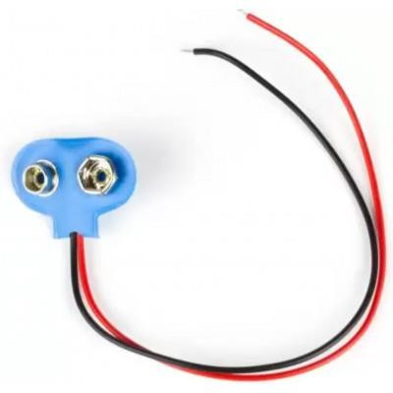

Fig: 3.12 Connectors

The battery has both terminals in a snap connector on one end. The smaller circular (male) terminal is positive, and the larger hexagonal or octagonal (female) minal is the negative contact.

The connectors on the battery are the same as on the connector itself, the smaller one connects to the larger one and vice versa. The same snap-style connector is used on other battery types in the Power Pack (PP) series

Battery polarization is normally obvious since mechanical connection is usually only possible in one configuration.

A problem with this style of connector is that it is very easy to connect two hatetics together in a short circuit, which quickly discharges batteries, generating heat and possibly a fire.

Because of this hazard, nine-volt batteries should be kept in the original packaging until they are going to be used.

### Working of Battery

A battery is a device that converts chemical energy directly to electrical energy, s of a number of voltaic cells, each voltaic cell consists of two half cells connected a conductive electrolyte containing anions and cations. One half-cell includes and the electrode to which anions (negatively-charged ions) migrime, i.e. the de or negative electrode.

The other half-cell includes electrolyte and the electrode to which cations gely-charged ions) migrate, i.e. the cathode or positive electrode. In the redox in that powers the battery, reduction (addition of electron occurs to cations at the diode while oxidation (removal of electrons) occurs to anions at the anode.

The electrodes do not touch each other but are electrically connected by the dly Many cells use two half-cells with different electrolytes. In that case each feel is enclosed in a container, and a separator that is porods to ions but not the bulk of the electrolytes prevents mixing

Each half cell has an electromotive force (or emf), determined by its ability to ave electric current from the interior to the exterior of the cell. The net emf of the cell is be difference between the emfs of its half-cells. Therefore, if the electrodes have emfx and other words, the net emf is the difference between the reduction potentials of the actions. The electrical driving force or across the terminals of a cell is known is the voltage (difference) and is measured in volts. The terminal voltage of a cell that her charging nor discharging is called the open- circuit voltage and equals the emf of the cell

Because of internal resistance, the terminal voltage of a cell that is discharging is aller in magnitile than the open-circuit voltage and the terminal voltage of a cell the charging exceeds the open-circuit voltage. An ideal cell has negligible internal mitance, so it would maintain a constant terminal voltage of until exhausted, then topping to zero.

If such a cell maintained 1.5 volts and stored a charge of one Coulomb then on amplete discharge it would perform 1.5 Joule of work. In actual cells, the internal resistance increases under discharge, and the open circuit voltage also decreases, under charge.

If the voltage and resistance are plotted against time, the resulting graphs typically are a curve the shape of the curve varies according to the chemistry and internal Arrangement employed.

## TRANSISTOR

### Introduction

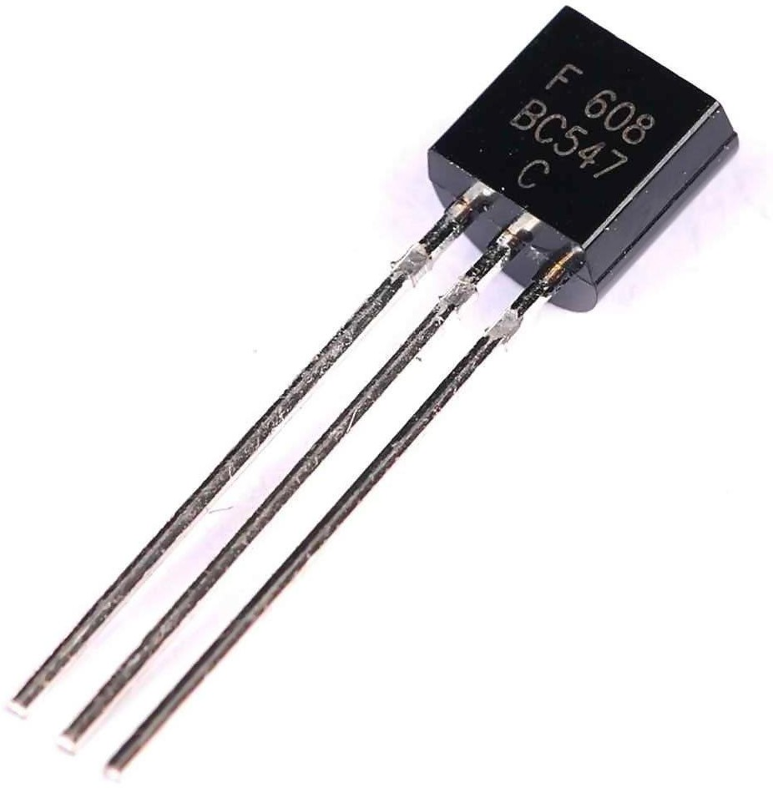

Fig: 3.13 Transistor

A transistor is a solid-state, semiconductor device with three electrical connections (emitter, base, and collector). A small current flowing between base and emitter has the ability to control a much larger current flowing between the collector and emitter. Transistors can be manufactured in two distinct configurations: PNP or NPN,

The N’s and P’s refer to the kind of impurity introduced into the crystal structure of the various regions of the transistor. This determines which way the currents flow through the transistor.

The circuit symbol for a transistor reveals its configuration by the direction of an arrow placed on the emitter lead and distinguishes the emitter from the collector as shown in Figure 1.

### NPN Transistor

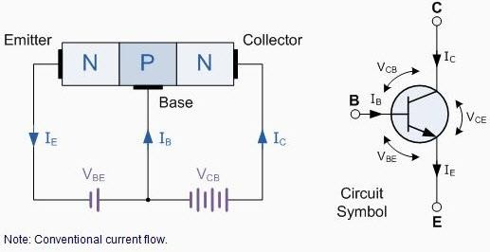

Fig:3.14 Construction and circuit symbol for NPN transistors

If, in the case of an NPN transistor, a positive voltage is applied to the collector (and the emitter connected to the negative terminal to complete the circuit) no current will flow unless a small current is allowed to flow through the base to the emitter. (For older types of transistor a small leakage current, uncontrolled by the 18, but dependent on the temperature. flows between the emitter and collector). The amount of collector current depends almost entirely on the amount of base current and the first part of the experiment is concerned with determining the extent of this dependence by plotting a set of curves known as the collector characteristics.

The collector characteristics are a family of curves showing the collector current flowing as a function of collector voltage for various values of base current as shown in Figure 2. From the collector characteristics the current amplification of the transistor may be determined.

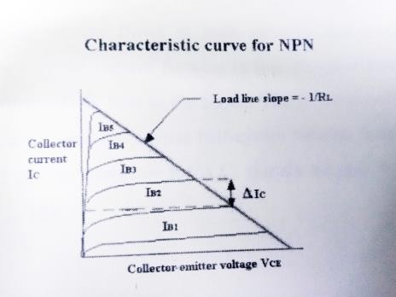

Fig: 3.15 Characteristic curves for a transistor

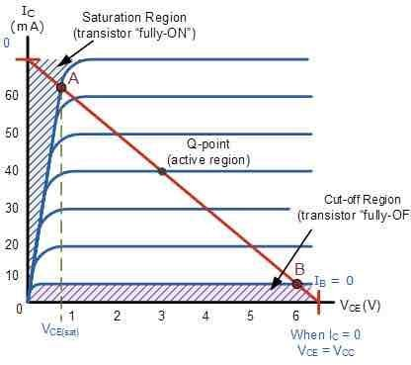

Fig: 3.16 Measurement parameters for hfe

### IR LEDs

An electroluminescent IR LED is a product which requires care in use. IR 11 are fabricated from narrow band heterostructures with energy gap from 0.25 to (I 4 eV 1 he's why the bias used to initiate current flow is low compared to the well-known visible NIR IJ Typical forward bias is V-0.1-1 V only for mid-IR LEDS!

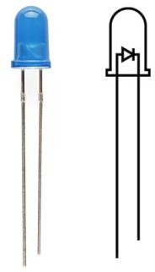

Fig: 3.17 LED

Be sure not to exceed Imax which is given in each LED specification and do no INC test instrument that contain sources batteries with voltage greater that V, was given in specification For LED current restriction and further LED come measurement: We recommend to use resistor (1-5 Ohms) connected in serial to LED

This is important to note that un-grounded devices (e.g. computers) can give 15 V that is enough to destroy the LED

It is highly desirable that the user has 1-V meter for all currents (10400×10.4 A). We guarantee the existence of the LED output.

We recommend activating pulse generator prior connecting LED to get on switching off the procedure is reversed: disconnect LED, switch off pulse generator, Long wires connecting LED with pulse generator may be the reason for LED failure because of unexpected voltage surges when switching on and off the LED supply.

Please test all elements and circuits before applying voltage to LED Remember that ground (T0-113 or another bolder) should be biased positively (if not specialty designed) Usually the negative electrode is made shorter than the positive anode. The expected signal is not very big and it is important to text and eliminate noise in the detector circuits

This effect can decreases LED emission power and can be traced due to the LED resistance decrease during each pulse. CW power often decreases with time due to heat sink temperature increase.

Micro immersion LEDs are made with chalcogenide glass that has low melting temperature (50-700C). That's why, please, avoid any heater source close to the LED. Even sunlight concentrated onto the lens can melt glass the lens. That's why we recommend vertical position for the LEDs at the initial stage of the research work.

## BUZZER

A buzzer or beeper is an audio signalling device, which may be mechanical electromechanical, or electronic. Typical uses of buzzers and beepers include alarms, timers and confirmation of user input such as a mouse click or keystroke.

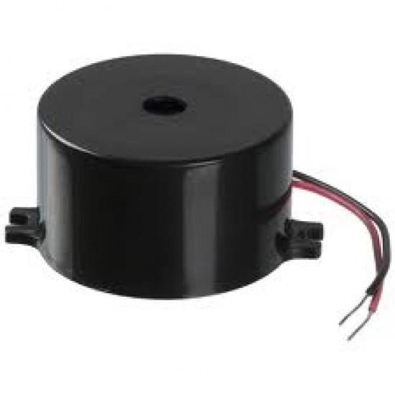

Fig: 3.18 Buzzer

#### Features

The PB series are high-performance buzzers with a unimorph piezoelectric ceramic element and an integral self-excitation oscillator circuit

They exhibit extremely low power consumption in comparison to electromagnetic units.

They are constructed without switching contacts to ensure long life and no electrical noise. Compact, yet produces high acoustic output with minimal voltage.

#### Mechanical

A joy buzzer is an example of a purely mechanical buzzer.

### Electromechanical

Early devices were based on an electromechanical system identical to an electric bell without the metal gong. Similarly, a relay may be connected to interrupt its own actuating current, causing the contacts to buzz. Often these units were anchored to a wall or ceiling to use it as a sounding board. The word "buzzer" comes from the rasping noise that electromechanical buzzers made.

#### Voltage Buzzer Sound Controls

When resistance is connected in series (as shown in illustrations (a) and (b)), abnormal oscillation may occur when adjusting the sound volume. In this case, insert a capacitor in parallel to the voltage oscillation board (as shown in illustration (é)), by doing so abral oscillation can be prevented by grounding one side.

However the voltage VI added to the voltage oscillation board must be within the maximum input voltage range and as capacitance of 3.3gF or greater should be connected.

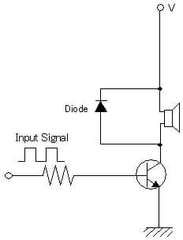

Fig: 3.19 Voltage Buzzer Sound Controls

### Electronic Buzzer

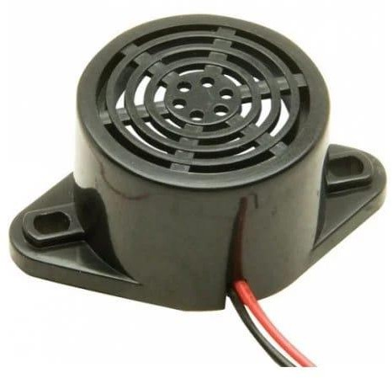

Fig: 3.20 Electronic Buzzer

## LASER POINTER

A laser consists of a gain medium inside a highly reflective optical cavity, as well as a means to supply energy to the gain medium. The gain medium is a material with properties that allow it to amplify light by stimulated emission. In its simplest form, a cavity consists of two mirrors arranged such that light bounces back and forth, each time passing through the gain medium.

Typically one of the two mirrors, the output coupler, is partially transparent. The output laser beam is emitted through this mirror. Light of a specific wavelength that passes through the gain medium is amplified (increases in power), the surrounding mirrors ensure that most of the light makes many passes through the gain medium, being amplified repeatedly. Part of the light that is between the mirrors (that is, within the cavity) passes through the partially transparent mirror and escapes as a beam of light.

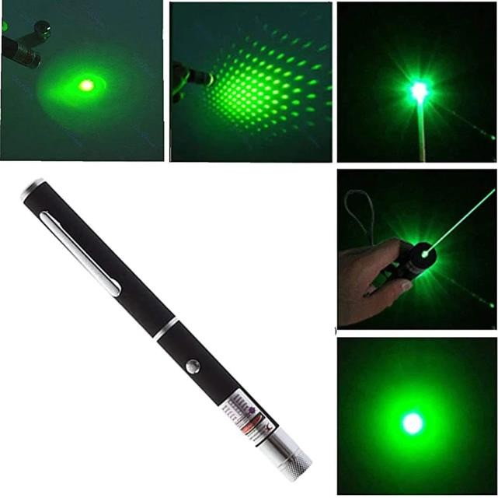The process of supplying the energy required for the amplification is called pumping. The energy is typically supplied as an electrical current or as light at a different wavelength. Such light may be provided by a flash lamp or perhaps another laser. Most practical lasers contain additional elements that affect properties such as the wavelength of the emitted light and the shape of the beam.

Fig: 3.21Laser Torch

For this project we have removed the laser assembly from a small laser pointer the power supply circuit is the green bound attached to the brass laser head. We carry similar laser pointers in our catalogue that are easily disassembled for this project. The power supply circuit came conveniently marked with a plus and a minus next to two holes in the board. We solder the black negative lead from the battery clip to the hole marked minus. We solder one of the coil leads to the whole marked plus. We solder the rest positive lead of the battery clip to the other lead from the coil.

1. Types
   1. Gas lasers
   2. Chemical lasers
   3. Excimer lasers
   4. Fibre-hosted lasers
   5. Photonic crystal lasers
   6. Semiconductor lasers
   7. Dye lasers
   8. Free electron lasers
2. USES:

Lasers range in size from microscopic diode lasers (top) with numerous applications, to football field sized neodymium glass lasers (bottom) used for inertial confinement fusion, nuclear weapons research and other high energy density physics experiments.

# CHAPTER – 4 PROPOSED SYSTEM

## INTRODUCTION

A security alarm is a system design need to detect intrusion - unauthorized entry into a building or area. The word LASER stands for Light Amplification by stimulated Emission of Radiation. These are available in different types like semiconductor, infrared GAS laser diode. This has an energy wavelength of approximately 900 nanometres with a heam divergence of 3 million radians equal to a beam width small beam width. Security alarms are used in residential commercial, industrial, and military properties for protection against burglary (theft) or property damage, as well as personal protection against intruders. Car alarms likewise protect vehicles and their contents. Prisons also use security systems for control of inmates.

Some alarm systems serve a single purpose of burglary protection, combination systems provide both fire and intrusion protection. Intrusion alarm systems may also be combined with closed-circuit television surveillance systems to automatically record the activities of intruders, and may interface to access control systems for electrically locked doors. Systems range from small, self-contained noisemakers, to complicated, multi-area systems with computer monitoring and control.

## BLOCK DIAGRAM

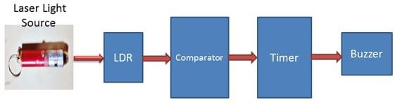

Fig: 4.1Block Diagram

### Explanation

* + - * LDR is a light dependent resistor which changes his resistance according to light
      * The comparator produces potential difference and is compared with reference voltage and generates a digital output as HIGH
      * The IC 555 timer required low trigger pulse to active buzzer and LED are deactivate.
      * When the laser light falls on LDR, the buzzer and LED lost light and the comparator's output becomes low.
      * The 555 timers also generate low trigger pulse and activates the buzzer and LED for a time period.

## CIRCUIT DIAGRAM

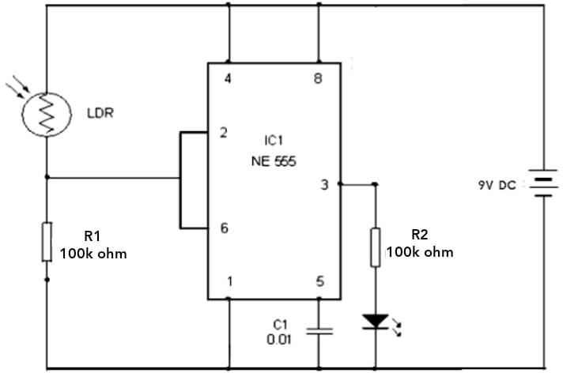

Fig:4.2 CIRCUIT DIAGRAM

## CIRCUIT DESIGN

* Pin 4 and Pin 8 are short circuited,
* Because in 4 is Active low pin and if it is leaved free and it will reset the flip flop, so to avoid such condition the pin 4 is connected to a "high" state
* Pin 2 and 6 are short circuited
* The LDR connected between Pin 2 and Pin 4; where it works as switch.
* A0.01 ul capacitor is connected between Pin 5 and Pin 1, to suppressany electrical noise generated within circuit
* The power supply is connected between Pin 1 and Pin 6 (9V)
* The output is generated at pin 3, it depends on the 'trigger pin
* The first led represents street light, it is connected between Pin 3 and
* Pin 8 with a 220 ohm resistor to protect the led.

### Working of the Project

A simple, cheap and effective laser based security system is developed in this project. Let us see the working of this project

First, the Op-Amp circuit acts as a comparator i.c. it compares the voltages at the inverting and non-inverting terminals and produces an output accordingly.

The LDR-10 Kohms resistor Voltage divider is connected to the non-inverting terminal of Op-Amp and a POT is connected to the inverting terminal

Assume, the laser pointer is placed directly in line of sight to the LDR and the light from the laser is continuously being incident on LDR. In this situation, the resistance of LDR falls down to few Ohms (or tens of Ohms)and as a result, the voltage at the non-inverting terminal will be less than that at theinventing voltage. The output of the Op-Amp is low and the transistor is OFF.

If the laser light is blocked by an intruder from falling on the LDR (even for a small duration), the resistance of the LDR goes to few hundreds of Ohms and as a result. The output of the Op-Amp will be HIGH. This will turn on the Transistor

As the output of the transistor is connected to the Trigger Pin (Pin 2) of the 555)

Timer IC, if the transistor is ON, the trigger pin gets a short low pulse and as a result, the output of the 555 becomes HIGH. This will activate the alarm by turning ON the buzzer.

Since, the 555 Timer IC is configured as a Bi-Stable Multivibrator, a small active low trigger pulse at the trigger pin will set its output to HIGH and in order to reset it we need to push the reset button.

Until the reset push button is pushed, the alarm will stay on hence, we can place the reset button at a secret location so that only the owner can disable the alarm.

## RESULT

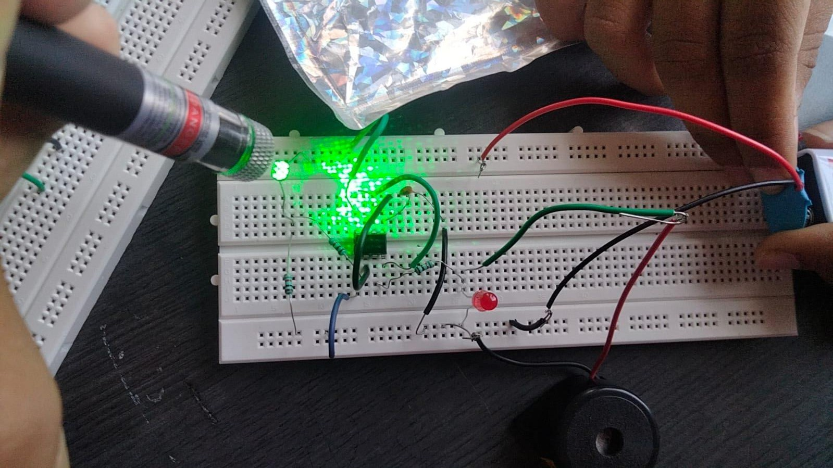

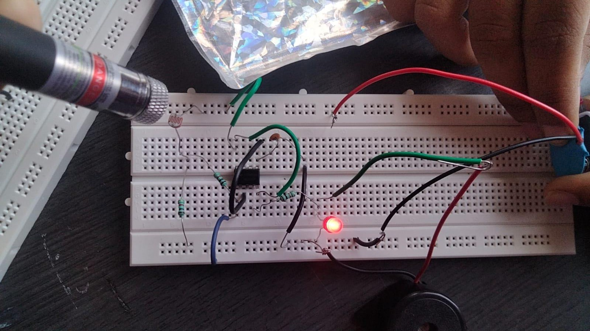

# CHAPTER – 5

## ADVANTAGES

* + - Laser security system locks working:
    - Laser Door alarm is based on discontinuity of laser light. The pointer is used source.
    - Theft detection by laser system:
    - It can be designed as simple electronic project to detect the thefts in banks, shopping malls, etc.

## APPLICATIONS

* + - A simple traffic light controller is implemented in this project with a real chance of expansion.
    - An external memory can be interface with the main controller so that the timings are not fixed during its programming but rather can be programmed during operation.
    - An efficient traffic light controller system will include a pedestrian signalling system.

# CHAPTER-6 CONCLUSION

Now a day's security is becoming very essential for every field. So, improvised technology in security system is needed. Security is important for offices, banks, shops, homes, etc. to be protected from theft. This project is a simple and easy one to provide security. Hence, this project has wide applications in all fields.

# REFERENCES

1. <http://www.electroschematics.com/4929/laser-based-door-alarm/>
2. <http://www.electronicsforu.com/newelectronics/defaultcampaign.asp>
3. [http://www.homesecurityguru.com/introduction-to-home-security-](http://www.homesecurityguru.com/introduction-to-home-security-%20%20%20%20%20systemsalanns-and-sensor)

[systemsalanns-and-sensor](http://www.homesecurityguru.com/introduction-to-home-security-%20%20%20%20%20systemsalanns-and-sensor)